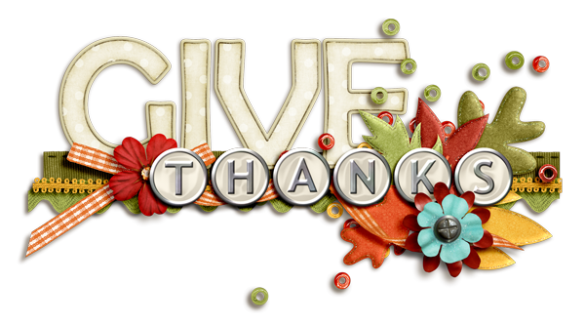

October 20, 2016

Dear Families of PCS,

As the holidays approach, PCS will again be hosting a collection for the Illinois Valley Food Pantry. As the need is even greater this year than ever before, we are asking you to help us provide a Thanksgiving dinner for needy families in our area. We will be collecting ***food*** or ***monetary*** donations from **October 21st** through **November 14th.**

**Here are some needed items:**

Canned yams stuffing mix

Canned vegetables cranberries

Canned pumpkin pie filings

Pancake syrup instant potatoes

Canned fruit Jell-O

Pudding cake mixes

**F.Y.I.** Student council is promoting the Food Drive by having a contest to see which classes can collect the most donations. The class with the most donations in K-4 and 5-8 will earn a popcorn & movie party. Start bringing in you items A.S.A.P! Each class will record their items.

.

C:\Documents and Settings\MrsQ\Local Settings\Temporary Internet Files\Content.IE5\UNY7IDYV\MCj04078020000[1].wmf